Adobe Forms – Dynamic Graphic Images

1. Upload the BMAP images at SE78  
   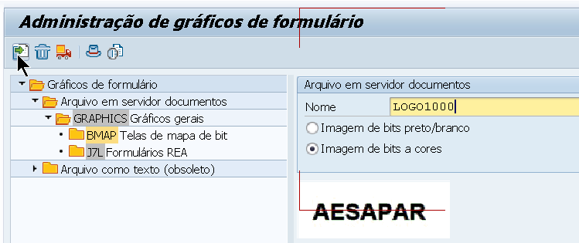
2. Assisgn it to a transport request
3. If you are using a different MANDT to test, use transaction SCC1 to transfer the images.
4. Go to transaction SFP - Form Builder, go to your interface
5. Create a GLOBAL Variable:  
   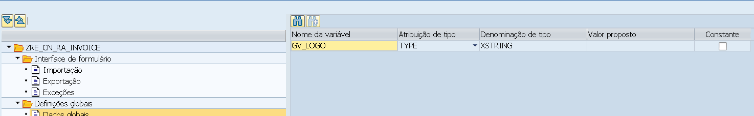
6. Load the image and transfer to the variable:  
   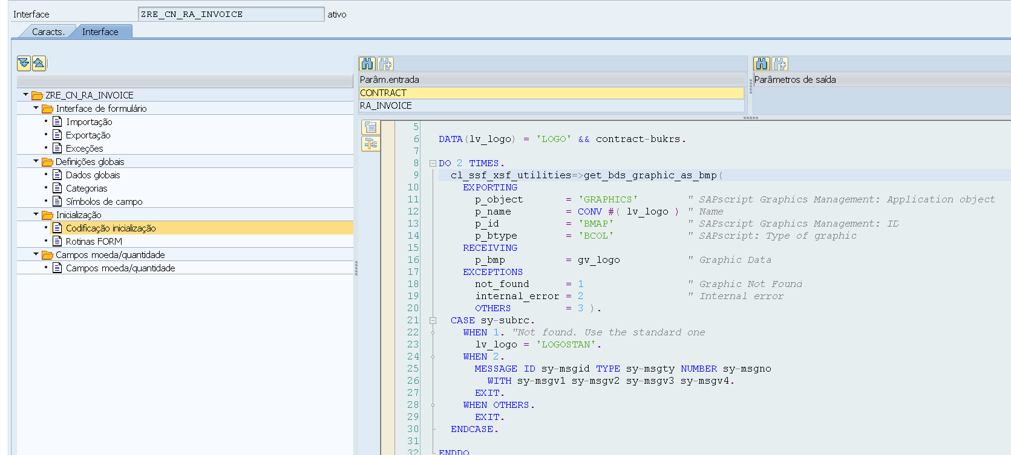
7. In your FORM, create a GRAPHIC element and assign the content of the global variable GV_LOGO  
   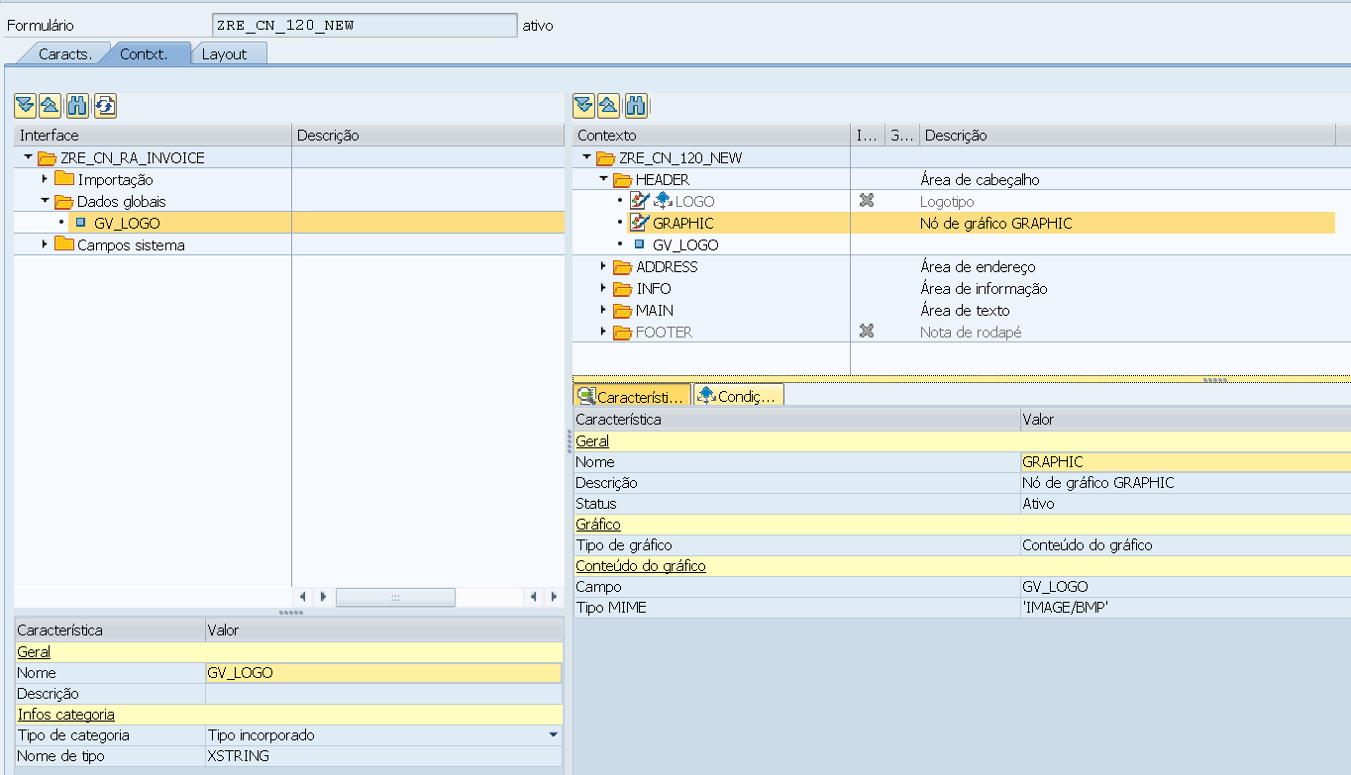  
   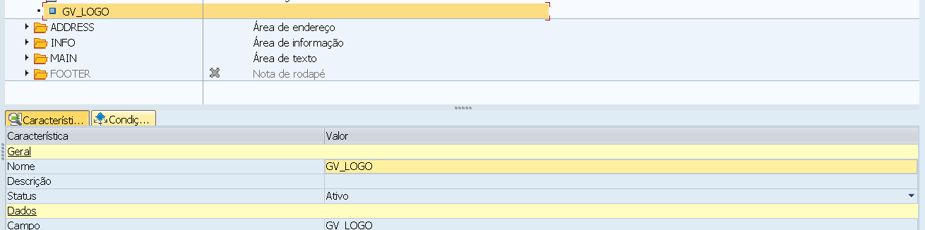
8. Go to the Layout TAB and create a FIELD of IMAGE  
   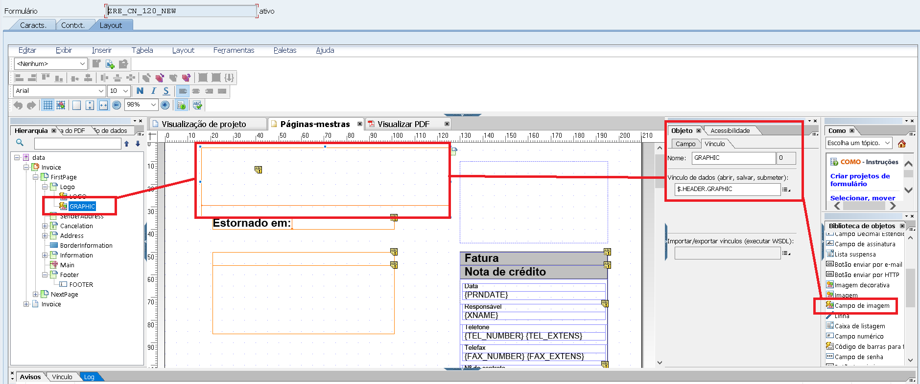
9. Do the binding:  
   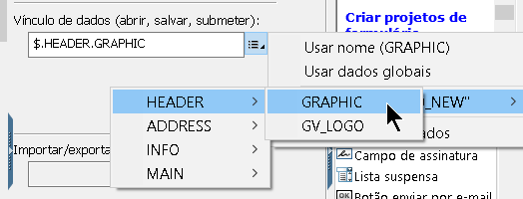
10. Test it  
    